Compiled by Roger Pfister http://RogerPf.com/aaBridge roger@RogerPf.com

You want to upload some hands to BBO.

You already have the deal or deals as a lin file
If you don't please look on the last page and see Enter (Type) Hands into aaBridge – a How to
You can upload the lin file to a folder on BBO in the normal way.
First login to BBO, go to Hands and Results and create a folder Folder.

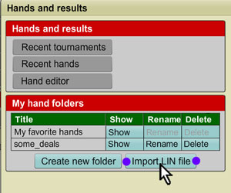
My BBO > Hands and Results > (blue button) Create new folder

For this example of lin file called some_deals.lin I would make a BBO folder called some_deals

Click the (blue button) Import LIN file (a dialog will appear)
Click the Select button for the folder you want to fill.
Click the (white) Choose file button and select the .lin where ever it is on your computer. (not shown)

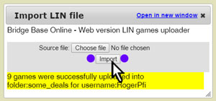
Click the (white) Import button
and you should see that all your deals (games) have been accepted by BBO.

On BBO you can use the uploaded files on a Teaching or Bidding table
To do this the table boss clicks the Deal source (blue button) near the center and then clicks Use saved deals and selects the folder they what to read the deals from.

Or the table boss can put a single deal on a Teaching or Bidding table by via
My BBO > Hands and Results
Click a folders Show (blue) button
Click a deals Show (blue) button
Click Export deal (blue button) near bottom of that panel
Click (menu item) Upload deal to table
Also see

NEW - the docs below are ALSO in the aaBridge Document Collection BUILT INTO aaBridge

Enter (Type) Hands into aaBridge - a How To

This is covered in a Blog post please see
http://musingsonbridge.rogerpf.com/2015/12/how-do-i-enter-type-hands-into-aabridge.html

How to get - Hands on BBO in to aaBridge

This is covered in a Blog post please see
http://musingsonbridge.rogerpf.com/2015/11/how-do-i-get-bbo-hand-into-aabridge.html

<end of document>

